CSC478 - Final Project Proposal

Airbnb House Analysis and Recommender Application

Team Member: Jie Bao, Lanny Xu, Kuangyi Zhang

## Overview

Airbnb provides the short-term leasing and renting service for people during tourism. Users could register and create their own account, then book different holiday cottages, apartments, homestays and hostel beds according to price, location, or review. In our project, by using the original dataset of Chicago’s airbnb house listings and user reviews, we provide host an evaluation of targeted residential housing market (data mining), as long as personalized recommendations to lodgers based on their selections or history records (recommender system).

## Dataset

### 1. Source

The data is published on the Inside Airbnb site, which is sourced from publicly available information from the Airbnb site. In our project, we use the **Listings** and **Reviews** dataset for Chicago, which was compiled on May 10th, 2017 and can be accessed through url below:

http://insideairbnb.com/get-the-data.html

### 2. Data Attributes

**Listings**

The dataset of Listings includes full descriptions of each listing and average review score.

Listings dataset: 5207 rows and 95 attributes

**#Location and environment#**

Id

Listing_url

Scrape_id Last_scraped

Name

Summary

Space

Description

Experiences_offered

Neighborhood_overview

Notes

Transit

Access

Interaction

House_rules

Thumbnail_url Medium_url picture_url xl_picture_url host_id host_url host_name

host_since host_location

host_about host_response_time host_response_rate host_acceptance_rate

host_is_superhost host_thumbnail_url host_picture_url host_neighbourhood

Host_listings_count

host_total_listings_count host_verifications host_has_profile_pic host_identity_verified street

neighbourhood

neighbourhood_cleansed neighbourhood_group_cleansed

**# Space and rent detail#**

City

State

Zipcode

Market

Smart_location Country_code Country

Latitude Longitude

Is_location_exact

Property_type Room_type

Accommodates Bathrooms bedrooms

Beds Bed_type Amenities Square_feet

Price

Weekly_price Monthly_price

Security_deposit Cleaning_fee Guests_included

extra_people minimum_nights maximum_nights

Calendar_updated

Has_availability

Availability_30 Availability_60 Availability_90 Availability_365 Calendar_last_scraped

**#Review#**

Number_of_reviews

First_reviewLast_review

Review_scores_rating Review_scores_accuracy Review_scores_cleanliness

Review_scores_checkin review_scores_communication review_scores_location

Review_scores_value

Requires_license License Jurisdiction_names

Instant_bookable Cancellation_policy

Require_guest_profile_picture require_guest_phone_verification

calculated_host_listings_count reviews_per_month

**Reviews**

The dataset of Reviews includes unique id for each reviewer and detailed comments.

Review dataset: 13605649 rows and 6 attributes

Listing_id

Id

Date

Reviewer_id

Reviewer_name

Comment

*Reviews data illustration:*

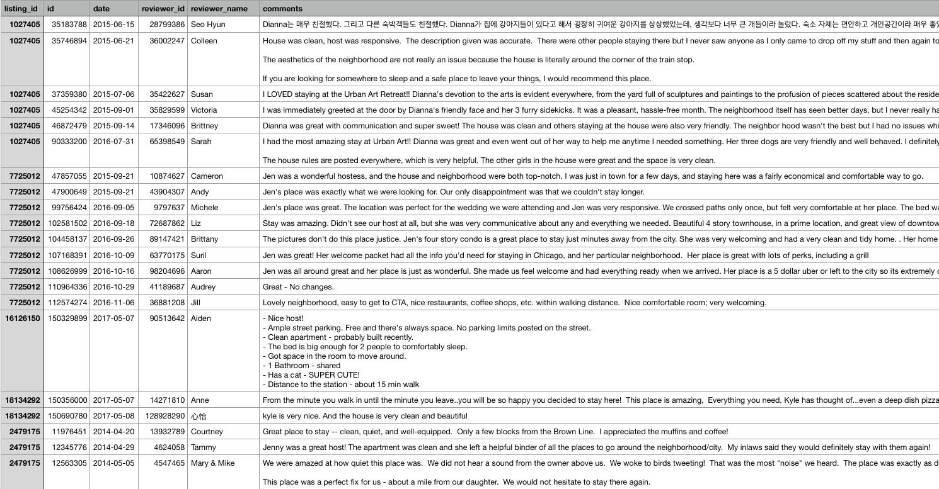

### Application Features

1. Data analysis for hosts

The application provides an insight of residential housing market to home hosts who plan to offer their accommodation service through Airbnb platform.

To do that, we first conduct data preprocessing and preparation on the original data, then apply data explorations, data visualization or other techniques on the data (e.g., classification, estimation, clustering, association rule discovery, etc.).

Home hosts can obtain basic information about the Airbnb listings in their neighborhoods, such as their locations, prices, type of homes and departments, or major customer types. Besides, our application can provide hosts with reasonable pricing range based on the home profile, or important home amenities features as an guidance to improve their popularity on Airbnb.

2. Recommender system for lodgers

On the other hand, the application help users to make their selection on Airbnb platform. On the basis of learning user’s rental history in Listings and Reviews data, it provides personalized recommendations through below two ways:

**To existing users:**

The application processes text mining based on user reviews history. By analyzing their comments and ratings on particular home, it discovers the users’ favourite features of home, and recommend similar homes to them.

**To new users:**

The application lists couples of most popular homes for user to choose at the very beginning. After user picks up the one he is interested in, the system will also recommend other homes with similar features to the one they have picked.